

FACULTY OF TECHNOLOGY AND ENGINEERING
DEVANG PATEL INSTITUTE OF ADVANCE TECHNOLOGY AND RESEARCH
DEPARTMENT OF INFORMATION TECHNOLOGY

A.Y. 2026-27 [SEMESTER 3]

LAB MANUAL

CEUE203: Object Oriented Programming


Practical 6

Interfaces, lambdas, and packages
Problem Statement:
1. Remote control: use Switchable devices, a default toggle, and an anonymous class and lambda policy.
2. Notification senders: broadcast through functional-interface lambdas and repeat urgent notifications.
3. Discount engine: choose a lambda rule at runtime and apply it to a list of prices.
Expected Output: The sample programs demonstrate the required behavior; see the captured console output below.

Solution:

DiscountEngine.java
import java.util.List;
import java.util.Scanner;
import java.util.function.UnaryOperator;
public class DiscountEngine {
public static void main(String[] args) {
List<Double> prices = List.of(100.0, 250.0, 500.0);
try (Scanner scanner = new Scanner(System.in)) {
System.out.print("Choose discount (1=10%, 2=20%, 3=flat 25): ");
int choice = scanner.nextInt();
UnaryOperator<Double> discount = switch (choice) {
case 1 -> price -> price * 0.90;
case 2 -> price -> price * 0.80;
case 3 -> price -> Math.max(0, price - 25);
default -> throw new IllegalArgumentException("Choose 1, 2, or 3.");
};
prices.stream().map(discount).forEach(price ->
System.out.printf("Discounted price: %.2f%n", price));
}
}
}

NotificationDemo.java
@FunctionalInterface
interface Notifier {
void send(String message);
}
interface Urgent { }
public class NotificationDemo {
private static final class EmailNotifier implements Notifier, Urgent {
@Override public void send(String message) {
System.out.println("Email: " + message);
}
}
private static final class SmsNotifier implements Notifier {
@Override public void send(String message) {
System.out.println("SMS: " + message);
}
}
public static void main(String[] args) {
Notifier[] senders = {new EmailNotifier(), new SmsNotifier(),
message -> System.out.println("Push: " + message)};
String message = "Your account statement is ready.";
for (Notifier sender : senders) sender.send(message);
for (Notifier sender : senders) {
if (sender instanceof Urgent) {
sender.send("URGENT: " + message);
sender.send("URGENT: " + message);
}
}
}
}

RemoteControlDemo.java
interface Switchable {
void on();
void off();
default void toggle() {
off();
on();
}
}
public class RemoteControlDemo {
private static final class Fan implements Switchable {
@Override public void on() { System.out.println("Fan on"); }
@Override public void off() { System.out.println("Fan off"); }
}
private static final class Light implements Switchable {
@Override public void on() { System.out.println("Light on"); }
@Override public void off() { System.out.println("Light off"); }
}
@FunctionalInterface
private interface SwitchPolicy {
boolean maySwitchOn(String device, int hour);
}
public static void main(String[] args) {
Switchable[] devices = {new Fan(), new Light()};
for (Switchable device : devices) device.toggle();
SwitchPolicy anonymousPolicy = new SwitchPolicy() {
@Override
public boolean maySwitchOn(String device, int hour) {
return hour >= 7 && hour < 22;
}
};
SwitchPolicy lambdaPolicy = (device, hour) -> hour >= 7 && hour < 22;
System.out.println("Anonymous policy at 20: "
+ anonymousPolicy.maySwitchOn("Fan", 20));
System.out.println("Lambda policy at 6: " + lambdaPolicy.maySwitchOn("Light", 6));
}
}

MiniBank Project Work:

MiniBank progress ? Practical 6
Completed: Transactable and InterestBearing capabilities, default yearly interest, the WithdrawRule functional interface, and the Premium marker interface. The central project organizes code into model, util, repository, and service packages.
Single project location: Java Programs\Minibank

Progressive source excerpts:

Minibank/src/main/java/minibank/model/Transactable.java
package minibank.model;
import minibank.exception.InsufficientFundsException;
import minibank.exception.InvalidAmountException;
public interface Transactable {
void deposit(long amount) throws InvalidAmountException;
boolean withdraw(long amount) throws InsufficientFundsException, InvalidAmountException;
}

Minibank/src/main/java/minibank/model/InterestBearing.java
package minibank.model;
public interface InterestBearing {
double interestRate();
default double yearlyInterest() {
return getBalance() * interestRate() / 100.0;
}
long getBalance();
}

Minibank/src/main/java/minibank/model/WithdrawRule.java
package minibank.model;
@FunctionalInterface
public interface WithdrawRule {
boolean allow(Account account, long amount);
}

Minibank/src/main/java/minibank/model/Premium.java
package minibank.model;
public interface Premium { }

Output Screenshot:
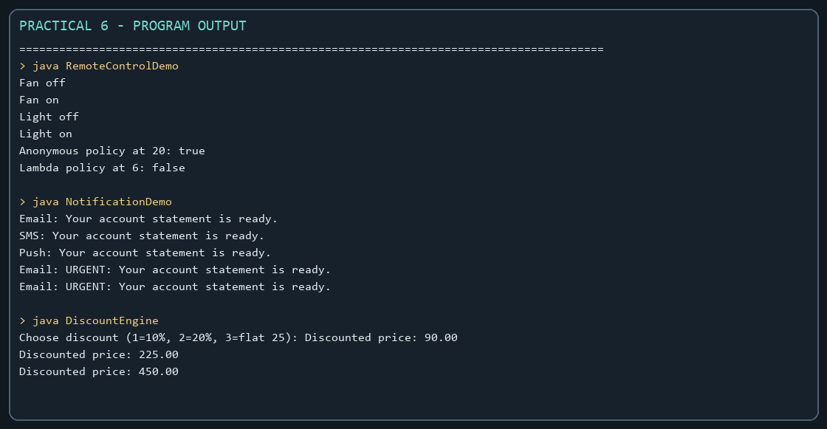

Practical 7

Annotations and reflection
Problem Statement:
1. Form validator: inspect runtime @NotBlank and @MaxLength annotations and report field errors.
2. Mini test runner: find and invoke only methods annotated with @Run.
3. Column mapper: map CSV-like header and row values to fields using @Column.
Expected Output: The sample programs demonstrate the required behavior; see the captured console output below.

Solution:

ColumnMapperDemo.java
import java.lang.annotation.ElementType;
import java.lang.annotation.Retention;
import java.lang.annotation.RetentionPolicy;
import java.lang.annotation.Target;
import java.lang.reflect.Field;
@Retention(RetentionPolicy.RUNTIME)
@Target(ElementType.FIELD)
@interface Column {
String value();
}
final class ImportedUser {
@Column("name") String name;
@Column("email") String email;
@Override public String toString() { return name + " <" + email + ">"; }
}
public class ColumnMapperDemo {
static ImportedUser map(String[] header, String[] row) throws ReflectiveOperationException {
if (header.length != row.length) throw new IllegalArgumentException("Column count mismatch.");
ImportedUser user = new ImportedUser();
for (Field field : ImportedUser.class.getDeclaredFields()) {
Column column = field.getAnnotation(Column.class);
for (int i = 0; i < header.length; i++) {
if (header[i].equals(column.value())) {
field.set(user, row[i]);
break;
}
}
if (field.get(user) == null) {
throw new IllegalArgumentException("Missing column: " + column.value());
}
}
return user;
}
public static void main(String[] args) throws ReflectiveOperationException {
System.out.println(map(new String[]{"email", "name"},
new String[]{"riya@example.com", "Riya"}));
}
}

FormValidatorDemo.java
import java.lang.annotation.ElementType;
import java.lang.annotation.Retention;
import java.lang.annotation.RetentionPolicy;
import java.lang.annotation.Target;
import java.lang.reflect.Field;
import java.util.ArrayList;
import java.util.List;
@Retention(RetentionPolicy.RUNTIME)
@Target(ElementType.FIELD)
@interface NotBlank { }
@Retention(RetentionPolicy.RUNTIME)
@Target(ElementType.FIELD)
@interface MaxLength {
int value();
}
final class SignupForm {
@NotBlank @MaxLength(30) private final String name;
@NotBlank @MaxLength(60) private final String email;
SignupForm(String name, String email) {
this.name = name;
this.email = email;
}
}
public class FormValidatorDemo {
static List<String> validate(Object object) throws IllegalAccessException {
List<String> errors = new ArrayList<>();
for (Field field : object.getClass().getDeclaredFields()) {
field.setAccessible(true);
Object value = field.get(object);
String text = value == null ? "" : value.toString();
if (field.isAnnotationPresent(NotBlank.class) && text.isBlank()) {
errors.add(field.getName() + " must not be blank");
}
MaxLength maxLength = field.getAnnotation(MaxLength.class);
if (maxLength != null && text.length() > maxLength.value()) {
errors.add(field.getName() + " exceeds " + maxLength.value() + " characters");
}
}
return errors;
}
public static void main(String[] args) throws IllegalAccessException {
System.out.println(validate(new SignupForm("", "a".repeat(70))));
System.out.println(validate(new SignupForm("Riya", "riya@example.com")));
}
}

MiniTestRunner.java
import java.lang.annotation.ElementType;
import java.lang.annotation.Retention;
import java.lang.annotation.RetentionPolicy;
import java.lang.annotation.Target;
import java.lang.reflect.InvocationTargetException;
import java.lang.reflect.Method;
@Retention(RetentionPolicy.RUNTIME)
@Target(ElementType.METHOD)
@interface Run { }
final class SampleTests {
@Run void addition() { if (2 + 2 != 4) throw new AssertionError("addition"); }
@Run void text() { if (!"java".toUpperCase().equals("JAVA")) throw new AssertionError("text"); }
void ignored() { throw new AssertionError("unmarked method ran"); }
}
public class MiniTestRunner {
public static void main(String[] args) throws ReflectiveOperationException {
Object target = new SampleTests();
int count = 0;
for (Method method : target.getClass().getDeclaredMethods()) {
if (method.isAnnotationPresent(Run.class)) {
try {
method.invoke(target);
count++;
System.out.println("PASS: " + method.getName());
} catch (InvocationTargetException exception) {
throw new AssertionError("Test failed: " + method.getName(),
exception.getCause());
}
}
}
System.out.println("Tests run: " + count);
}
}

MiniBank Project Work:

MiniBank progress ? Practical 7
Completed: runtime @Id, @Positive, and @MaxLength metadata; Account fields are annotated, and AnnotationValidator reads annotated model metadata by reflection.
Single project location: Java Programs\Minibank

Progressive source excerpts:

Minibank/src/main/java/minibank/model/annotation/Id.java
package minibank.model.annotation;
import java.lang.annotation.ElementType;
import java.lang.annotation.Retention;
import java.lang.annotation.RetentionPolicy;
import java.lang.annotation.Target;
@Retention(RetentionPolicy.RUNTIME)
@Target(ElementType.FIELD)
public @interface Id { }

Minibank/src/main/java/minibank/model/annotation/Positive.java
package minibank.model.annotation;
import java.lang.annotation.ElementType;
import java.lang.annotation.Retention;
import java.lang.annotation.RetentionPolicy;
import java.lang.annotation.Target;
@Retention(RetentionPolicy.RUNTIME)
@Target(ElementType.FIELD)
public @interface Positive {
String message() default "must be > 0";
}

Minibank/src/main/java/minibank/model/annotation/MaxLength.java
package minibank.model.annotation;
import java.lang.annotation.ElementType;
import java.lang.annotation.Retention;
import java.lang.annotation.RetentionPolicy;
import java.lang.annotation.Target;
@Retention(RetentionPolicy.RUNTIME)
@Target(ElementType.FIELD)
public @interface MaxLength {
int value();
}

Minibank/src/main/java/minibank/util/AnnotationValidator.java
package minibank.util;
import java.lang.reflect.Field;
import java.util.ArrayList;
import java.util.List;
import minibank.model.annotation.MaxLength;
import minibank.model.annotation.Positive;
public final class AnnotationValidator {
private AnnotationValidator() { }
public static String[] validate(Object object) {
List<String> errors = new ArrayList<>();
for (Class<?> type = object.getClass(); type != null; type = type.getSuperclass()) {
for (Field field : type.getDeclaredFields()) {
try {
field.setAccessible(true);
Object value = field.get(object);
Positive positive = field.getAnnotation(Positive.class);
if (positive != null && value instanceof Number number
&& number.longValue() <= 0) {
errors.add(field.getName() + " " + positive.message());
}
MaxLength maxLength = field.getAnnotation(MaxLength.class);
if (maxLength != null && value instanceof String text
&& text.length() > maxLength.value()) {
errors.add(field.getName() + " exceeds " + maxLength.value() + " characters");
}
} catch (IllegalAccessException exception) {
throw new IllegalStateException("Unable to validate " + field.getName(), exception);
}
}
}
return errors.toArray(String[]::new);
}
}

Output Screenshot:
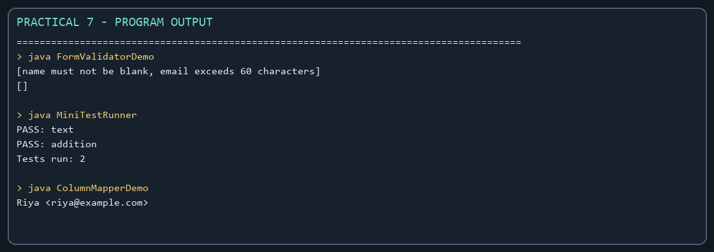

Practical 8

Exception handling and resource management
Problem Statement:
1. Guarded calculator: handle invalid numbers and division by zero, retry, and record each attempt in finally.
2. Warehouse issue: use checked stock and quantity exceptions while continuing through all requests.
3. AutoCloseable resource: demonstrate closure after failure while retaining the original exception.
Expected Output: The sample programs demonstrate the required behavior; see the captured console output below.

Solution:

GuardedCalculator.java
import java.util.Scanner;
public class GuardedCalculator {
private static final class DivideByZeroException extends Exception {
private static final long serialVersionUID = 1L;
DivideByZeroException() { super("Cannot divide by zero."); }
}
private static double calculate(double left, double right, String operator)
throws DivideByZeroException {
return switch (operator) {
case "+" -> left + right;
case "-" -> left - right;
case "*" -> left * right;
case "/" -> {
if (right == 0) throw new DivideByZeroException();
yield left / right;
}
default -> throw new IllegalArgumentException("Operator must be +, -, *, or /.");
};
}
public static void main(String[] args) {
try (Scanner scanner = new Scanner(System.in)) {
while (true) {
System.out.print("Enter calculation (number operator number): ");
try {
double left = Double.parseDouble(scanner.next());
String operator = scanner.next();
double right = Double.parseDouble(scanner.next());
System.out.println("Result: " + calculate(left, right, operator));
break;
} catch (NumberFormatException exception) {
System.out.println("Invalid number. Try again.");
scanner.nextLine();
} catch (DivideByZeroException | IllegalArgumentException exception) {
System.out.println(exception.getMessage());
scanner.nextLine();
} finally {
System.out.println("Calculation attempt recorded.");
}
}
}
}
}

ResourceDemo.java
public class ResourceDemo {
private static final class SampleResource implements AutoCloseable {
private boolean closed;
void use() {
if (closed) throw new IllegalStateException("Resource is already closed.");
System.out.println("Resource is open.");
}
@Override
public void close() {
closed = true;
System.out.println("Resource closed.");
}
}
public static void main(String[] args) {
try (SampleResource resource = new SampleResource()) {
resource.use();
throw new IllegalStateException("Original failure");
} catch (IllegalStateException exception) {
System.out.println("Reported: " + exception.getMessage());
}
}
}

WarehouseDemo.java
import java.util.Map;
public class WarehouseDemo {
private static final class OutOfStockException extends Exception {
private static final long serialVersionUID = 1L;
private final int shortfall;
OutOfStockException(int shortfall) {
super("Out of stock by " + shortfall);
this.shortfall = shortfall;
}
int shortfall() { return shortfall; }
}
private static final class InvalidQuantityException extends Exception {
private static final long serialVersionUID = 1L;
InvalidQuantityException() { super("Quantity must be positive."); }
}
private static final class Warehouse {
private final Map<String, Integer> stock = new java.util.HashMap<>(
Map.of("Pen", 3, "Book", 1));
void issue(String item, int quantity)
throws OutOfStockException, InvalidQuantityException {
if (quantity <= 0) throw new InvalidQuantityException();
int available = stock.getOrDefault(item, 0);
if (quantity > available) throw new OutOfStockException(quantity - available);
stock.put(item, available - quantity);
System.out.println("Issued " + quantity + " " + item);
}
}
public static void main(String[] args) {
Warehouse warehouse = new Warehouse();
String[][] requests = {{"Pen", "2"}, {"Book", "3"}, {"Pen", "0"}, {"Pencil", "1"}};
for (String[] request : requests) {
try {
warehouse.issue(request[0], Integer.parseInt(request[1]));
} catch (OutOfStockException exception) {
System.out.println(exception.getMessage() + " (shortfall "
+ exception.shortfall() + ")");
} catch (InvalidQuantityException exception) {
System.out.println(exception.getMessage());
}
}
}
}

MiniBank Project Work:

MiniBank progress ? Practical 8
Completed: checked BankException subclasses carry explicit banking failures; deposit, withdraw, and transfer validate amounts and report insufficient funds instead of silently returning failure.
Single project location: Java Programs\Minibank

Progressive source excerpts:

Minibank/src/main/java/minibank/exception/BankException.java
package minibank.exception;
public class BankException extends Exception {
private static final long serialVersionUID = 1L;
public BankException(String message) { super(message); }
}

Minibank/src/main/java/minibank/exception/InsufficientFundsException.java
package minibank.exception;
public final class InsufficientFundsException extends BankException {
private static final long serialVersionUID = 1L;
private final long shortfall;
public InsufficientFundsException(long shortfall) {
super("Insufficient funds; short by " + shortfall + ".");
this.shortfall = shortfall;
}
public long getShortfall() { return shortfall; }
}

Minibank/src/main/java/minibank/exception/InvalidAmountException.java
package minibank.exception;
public final class InvalidAmountException extends BankException {
private static final long serialVersionUID = 1L;
public InvalidAmountException(String message) { super(message); }
}

Minibank/src/main/java/minibank/exception/AccountNotFoundException.java
package minibank.exception;
public final class AccountNotFoundException extends BankException {
private static final long serialVersionUID = 1L;
public AccountNotFoundException(String accountNumber) {
super("Account not found: " + accountNumber);
}
}

Minibank/src/main/java/minibank/model/Account.java ? checked withdrawal
public synchronized boolean withdraw(long amount)
throws InsufficientFundsException, InvalidAmountException {
if (amount <= 0) throw new InvalidAmountException("Withdrawal must be positive.");
if (!canWithdraw(amount)) {
throw new InsufficientFundsException(Math.max(0, amount - balance));
}
balance = Math.subtractExact(balance, amount);
return true;
}

Minibank/src/main/java/minibank/service/BankService.java ? transfer
public void transfer(String fromNumber, String toNumber, long amount)
throws BankException, IOException {
Account from = find(fromNumber);
Account to = find(toNumber);
if (from.equals(to)) throw new IllegalArgumentException("Transfer accounts must differ.");
Account first = Comparator.comparing(Account::getAccountNumber).compare(from, to) < 0
? from : to;
Account second = first == from ? to : from;
synchronized (first) {
synchronized (second) {
from.withdraw(amount);
try {
to.deposit(amount);
} catch (InvalidAmountException | ArithmeticException exception) {
from.deposit(amount);
throw exception;
}
}
}
TransactionLog.append(logFile, "WITHDRAW " + amount);
TransactionLog.append(logFile, "DEPOSIT " + amount);
}

Output Screenshot:
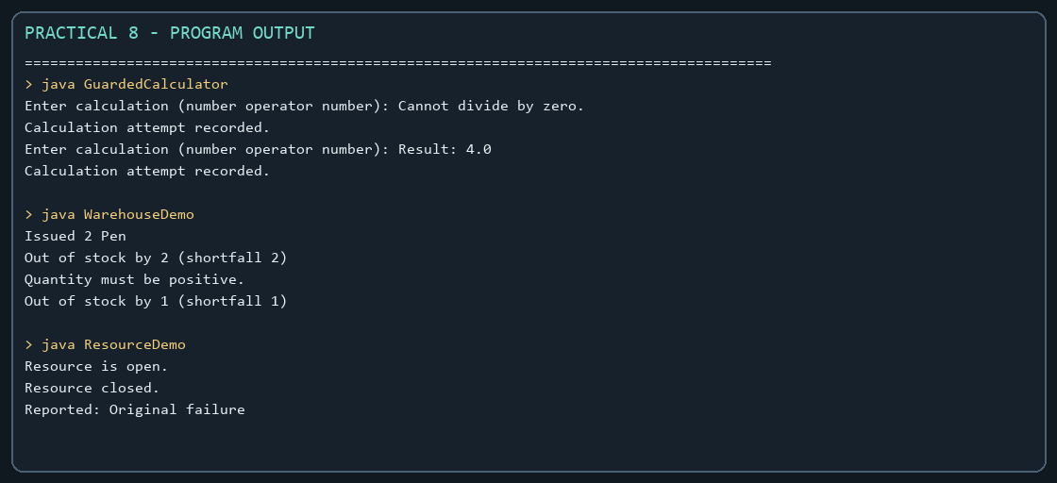

Practical 9

Threads, races, and synchronization
Problem Statement:
1. Counter race: compare unsynchronized and synchronized increments across multiple threads.
2. Seat booking race: coordinate concurrent customers so only available seats are sold.
3. Parallel sum: split an array across workers and combine partial totals safely.

Solution:

CounterRace.java
import java.util.concurrent.CountDownLatch;
public class CounterRace {
private static final class Counter {
private int value;
void incrementWithoutLock() { value++; }
synchronized void incrementWithLock() { value++; }
int value() { return value; }
}
public static void main(String[] args) throws InterruptedException {
int workers = 8;
int increments = 500_000;
Counter unsafeCounter = new Counter();
runWorkers(unsafeCounter, workers, increments, false);
System.out.println("Unsynchronized count: " + unsafeCounter.value());
System.out.println("Expected count: " + (workers * increments));
Counter safeCounter = new Counter();
runWorkers(safeCounter, workers, increments, true);
System.out.println("Synchronized count: " + safeCounter.value());
}
private static void runWorkers(Counter counter, int workers, int increments, boolean safe)
throws InterruptedException {
CountDownLatch start = new CountDownLatch(1);
Thread[] threads = new Thread[workers];
for (int i = 0; i < workers; i++) {
threads[i] = new Thread(() -> {
try {
start.await();
} catch (InterruptedException exception) {
Thread.currentThread().interrupt();
return;
}
for (int j = 0; j < increments; j++) {
if (safe) counter.incrementWithLock();
else counter.incrementWithoutLock();
}
}, "counter-" + i);
threads[i].start();
}
start.countDown();
for (Thread thread : threads) thread.join();
}
}

ParallelSum.java
import java.util.concurrent.atomic.LongAdder;
public class ParallelSum {
public static void main(String[] args) throws InterruptedException {
long[] numbers = new long[100_000];
for (int i = 0; i < numbers.length; i++) numbers[i] = i + 1L;
LongAdder total = new LongAdder();
int workers = 4;
Thread[] threads = new Thread[workers];
for (int worker = 0; worker < workers; worker++) {
int start = worker * numbers.length / workers;
int end = (worker + 1) * numbers.length / workers;
threads[worker] = new Thread(() -> {
long partial = 0;
for (int i = start; i < end; i++) partial += numbers[i];
total.add(partial);
});
threads[worker].start();
}
for (Thread thread : threads) thread.join();
long expected = (long) numbers.length * (numbers.length + 1) / 2;
System.out.println("Parallel sum: " + total.sum());
System.out.println("Expected: " + expected);
}
}

SeatBookingRace.java
import java.util.concurrent.atomic.AtomicInteger;
import java.util.concurrent.CountDownLatch;
public class SeatBookingRace {
private static final class BookingOffice {
private int seatsLeft = 5;
private int booked;
boolean bookWithoutSynchronization(CountDownLatch checked, CountDownLatch release)
throws InterruptedException {
if (seatsLeft == 0) return false;
checked.countDown();
release.await();
seatsLeft--;
booked++;
return true;
}
synchronized boolean book() {
if (seatsLeft == 0) return false;
seatsLeft--;
booked++;
return true;
}
synchronized int booked() { return booked; }
}
public static void main(String[] args) throws InterruptedException {
int customersCount = 10;
BookingOffice unsafeOffice = new BookingOffice();
AtomicInteger unsafeBookings = new AtomicInteger();
CountDownLatch checked = new CountDownLatch(customersCount);
CountDownLatch release = new CountDownLatch(1);
Thread[] customers = new Thread[customersCount];
for (int i = 0; i < customers.length; i++) {
customers[i] = new Thread(() -> {
try {
if (unsafeOffice.bookWithoutSynchronization(checked, release)) {
unsafeBookings.incrementAndGet();
}
} catch (InterruptedException exception) {
Thread.currentThread().interrupt();
}
}, "unsafe-customer-" + i);
customers[i].start();
}
checked.await();
release.countDown();
for (Thread customer : customers) customer.join();
System.out.println("Unsynchronized bookings: " + unsafeBookings.get());
BookingOffice safeOffice = new BookingOffice();
AtomicInteger safeBookings = new AtomicInteger();
for (int i = 0; i < customersCount; i++) {
customers[i] = new Thread(() -> {
if (safeOffice.book()) safeBookings.incrementAndGet();
}, "safe-customer-" + i);
customers[i].start();
}
for (Thread customer : customers) customer.join();
System.out.println("Synchronized bookings: " + safeBookings.get());
System.out.println("Seats booked: " + safeOffice.booked());
}
}

MiniBank Project Work:

MiniBank progress ? Practical 9
Completed: Account deposit, withdraw, and balance access are synchronized. AccountWorker supplies the Runnable task that performs repeated deposits from named worker threads.
Single project location: Java Programs\Minibank

Progressive source excerpts:

Minibank/src/main/java/minibank/model/Account.java ? thread-safe deposit
public synchronized void deposit(long amount) throws InvalidAmountException {
if (amount <= 0) throw new InvalidAmountException("Deposit must be positive.");
balance = Math.addExact(balance, amount);
}

Minibank/src/main/java/minibank/model/Account.java ? thread-safe withdrawal
public synchronized boolean withdraw(long amount)
throws InsufficientFundsException, InvalidAmountException {
if (amount <= 0) throw new InvalidAmountException("Withdrawal must be positive.");
if (!canWithdraw(amount)) {
throw new InsufficientFundsException(Math.max(0, amount - balance));
}
balance = Math.subtractExact(balance, amount);
return true;
}

Minibank/src/main/java/minibank/service/AccountWorker.java
package minibank.service;
import minibank.exception.InvalidAmountException;
import minibank.model.Account;
public final class AccountWorker implements Runnable {
private final Account account;
private final int times;
private final long amount;
public AccountWorker(Account account, int times, long amount) {
if (times < 0) throw new IllegalArgumentException("Times cannot be negative.");
this.account = account;
this.times = times;
this.amount = amount;
}
@Override
public void run() {
for (int i = 0; i < times; i++) {
try {
account.deposit(amount);
System.out.println(Thread.currentThread().getName() + " deposited " + amount);
} catch (InvalidAmountException exception) {
System.err.println("Deposit failed: " + exception.getMessage());
return;
}
}
}
}

Output Screenshot:
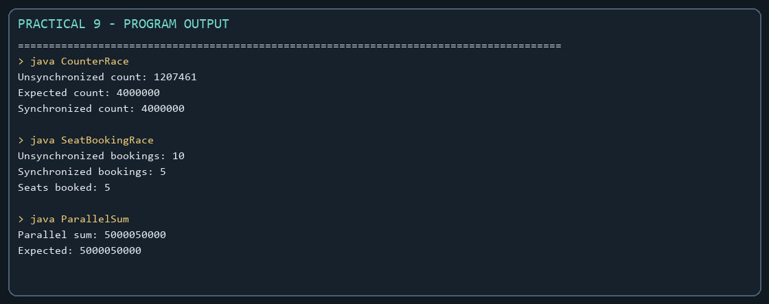

Practical 10

Thread pools and coordination
Problem Statement:
1. Thread-pool runner: execute ten tasks on a fixed pool and await completion.
2. Producer-consumer: coordinate a bounded buffer with wait and notify.
3. Deadlock: show opposite lock order and then finish transfers using a consistent order.

Solution:

DeadlockDemo.java
import java.util.concurrent.CountDownLatch;
public class DeadlockDemo {
private static final Object FIRST = new Object();
private static final Object SECOND = new Object();
private static final Object HASH_COLLISION_LOCK = new Object();
private static void unsafeTransfer(Object first, Object second, CountDownLatch ready) {
synchronized (first) {
ready.countDown();
try {
ready.await();
} catch (InterruptedException exception) {
Thread.currentThread().interrupt();
return;
}
synchronized (second) {
System.out.println("Unsafe transfer completed.");
}
}
}
private static void safeTransfer(Object first, Object second) {
int firstHash = System.identityHashCode(first);
int secondHash = System.identityHashCode(second);
if (firstHash == secondHash) {
synchronized (HASH_COLLISION_LOCK) {
lockAndTransfer(first, second);
}
} else if (firstHash < secondHash) {
lockAndTransfer(first, second);
} else {
lockAndTransfer(second, first);
}
}
private static void lockAndTransfer(Object first, Object second) {
synchronized (first) {
synchronized (second) {
System.out.println("Ordered transfer completed.");
}
}
}
public static void main(String[] args) throws InterruptedException {
CountDownLatch ready = new CountDownLatch(2);
Thread a = new Thread(() -> unsafeTransfer(FIRST, SECOND, ready), "unsafe-A");
Thread b = new Thread(() -> unsafeTransfer(SECOND, FIRST, ready), "unsafe-B");
a.setDaemon(true);
b.setDaemon(true);
a.start();
b.start();
Thread.sleep(200);
System.out.println("Opposite lock order deadlock observed: "
+ (a.isAlive() && b.isAlive()));
Object accountA = new Object();
Object accountB = new Object();
Thread safeA = new Thread(() -> safeTransfer(accountA, accountB));
Thread safeB = new Thread(() -> safeTransfer(accountB, accountA));
safeA.start();
safeB.start();
safeA.join();
safeB.join();
}
}

ProducerConsumerDemo.java
import java.util.ArrayDeque;
import java.util.Queue;
public class ProducerConsumerDemo {
private static final class Buffer {
private final Queue<Integer> values = new ArrayDeque<>();
private final int capacity;
Buffer(int capacity) { this.capacity = capacity; }
synchronized void put(int value) throws InterruptedException {
while (values.size() == capacity) wait();
values.add(value);
notifyAll();
}
synchronized int take() throws InterruptedException {
while (values.isEmpty()) wait();
int value = values.remove();
notifyAll();
return value;
}
}
public static void main(String[] args) throws InterruptedException {
Buffer buffer = new Buffer(2);
Thread producer = new Thread(() -> {
try {
for (int value = 1; value <= 8; value++) buffer.put(value);
buffer.put(-1);
} catch (InterruptedException exception) {
Thread.currentThread().interrupt();
}
}, "producer");
Thread consumer = new Thread(() -> {
try {
int value;
while ((value = buffer.take()) != -1) System.out.println("Consumed: " + value);
} catch (InterruptedException exception) {
Thread.currentThread().interrupt();
}
}, "consumer");
producer.start();
consumer.start();
producer.join();
consumer.join();
}
}

ThreadPoolRunner.java
import java.util.concurrent.ExecutorService;
import java.util.concurrent.Executors;
import java.util.concurrent.TimeUnit;
public class ThreadPoolRunner {
public static void main(String[] args) throws InterruptedException {
ExecutorService pool = Executors.newFixedThreadPool(3);
for (int task = 1; task <= 10; task++) {
int id = task;
pool.submit(() -> {
System.out.println("Task " + id + " on " + Thread.currentThread().getName());
try {
Thread.sleep(100);
} catch (InterruptedException exception) {
Thread.currentThread().interrupt();
}
});
}
pool.shutdown();
if (!pool.awaitTermination(5, TimeUnit.SECONDS)) {
pool.shutdownNow();
throw new IllegalStateException("Tasks did not finish before timeout.");
}
}
}

MiniBank Project Work:

MiniBank progress ? Practical 10
Completed: TransactionProcessor runs tasks on a fixed four-thread pool and waits for shutdown. Transfers consistently lock accounts in account-number order to avoid opposite-order deadlock.
Single project location: Java Programs\Minibank

Progressive source excerpts:

Minibank/src/main/java/minibank/service/TransactionProcessor.java
package minibank.service;
import java.time.Duration;
import java.util.Objects;
import java.util.concurrent.ExecutorService;
import java.util.concurrent.Executors;
import java.util.concurrent.TimeUnit;
public final class TransactionProcessor implements AutoCloseable {
private final ExecutorService executor = Executors.newFixedThreadPool(4);
public void submit(Runnable task) {
executor.execute(Objects.requireNonNull(task));
}
public void stop() {
executor.shutdown();
try {
if (!executor.awaitTermination(Duration.ofSeconds(30).toMillis(), TimeUnit.MILLISECONDS)) {
executor.shutdownNow();
if (!executor.awaitTermination(5, TimeUnit.SECONDS)) {
throw new IllegalStateException("Transaction tasks did not terminate.");
}
}
} catch (InterruptedException exception) {
executor.shutdownNow();
Thread.currentThread().interrupt();
throw new IllegalStateException("Interrupted while stopping transaction processor.",
exception);
}
}
@Override public void close() { stop(); }
}

Minibank/src/main/java/minibank/service/BankService.java ? ordered transfer locks
public void transfer(String fromNumber, String toNumber, long amount)
throws BankException, IOException {
Account from = find(fromNumber);
Account to = find(toNumber);
if (from.equals(to)) throw new IllegalArgumentException("Transfer accounts must differ.");
Account first = Comparator.comparing(Account::getAccountNumber).compare(from, to) < 0
? from : to;
Account second = first == from ? to : from;
synchronized (first) {
synchronized (second) {
from.withdraw(amount);
try {
to.deposit(amount);
} catch (InvalidAmountException | ArithmeticException exception) {
from.deposit(amount);
throw exception;
}
}
}
TransactionLog.append(logFile, "WITHDRAW " + amount);
TransactionLog.append(logFile, "DEPOSIT " + amount);
}

Output Screenshot:


